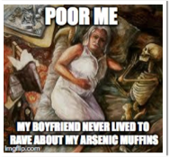

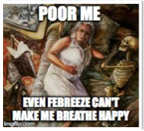

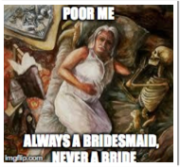

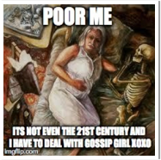

**Memes as Motifs: New Media Assignment for Intro to Lit**

A meme is very similar to a motif in literature because it features a repetitive element that the audience can recognize. For example, the meme “Bad Luck Brian” always has the same picture of Brian accompanied by bad news. In Gothic literature, we also see/ examine repetitive patterns. Thinking of memes in this way, allows us to practice utilizing common tropes from our text. With their meme group, students designed their own memes using a particular motif for a basis. They came up with the repeating feature, which may have been an image, a phrase, or an expression. They created a meme “mini series” of five or six depending on the group size (one per person in the group). There were several different approaches they could take for this assignment: They could choose to focus on one particular character, author, or story. Or they could create memes with a common theme or saying that covered a span of our readings.  I told them to feel free to use pop culture references that they believed were fitting for the topic or text.

The memes on the right are based on the text, “A Rose for Emily.” The group’s motif was the distressed heroine. As you can see, the group’s common elements include the picture of Emily, and the words “poor me.” The distinctive feature (the other words) are direct references to the text. From the top down: Emily poisons Homer with arsenic, the community uses lime to help stifle the smell in Emily’s home, Emily wants to marry Homer, but is denied her opportunity, and Emily becomes prey to town gossip because of her relationship with a Yankee.

**Meeting Goals and Outcomes:**

**Students will demonstrate an understanding of literature as it impacts or reflects the individual through class discussion, research, and exam questions.**

Students demonstrated their understanding of the texts by dissecting a particular character, scene, or motif in order to examine an argument made by the author, character, or text in meme form. As seen by these memes, the student group felt Miss Emily was both a repulsive and sympathetic character, constantly “playing the victim.”

**Interact with the text culturally and communally through various mediums: blogs, memes, and youtube**.

I believe when students make personal connections with the text, they remember it longer. Creating memes out of the text brings the story into the present and allows them to grapple with the ideas of motifs in a new way.

**Identify common themes and motifs within the texts**

As explained above, students were broken into groups based on motifs and were asked to demonstrate their knowledge of how the motif appeared in the text of their choice. The phrase “poor me” symbolizes the idea of Emily as a distressed heroine.